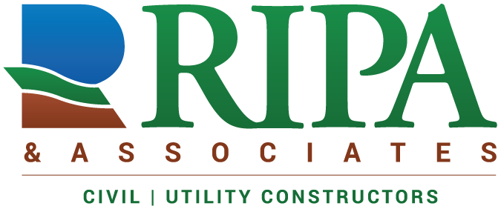 Fleet Shop Technician

Job Description
Job Title:
Fleet Shop Technician

Starting Salary: $20/hour

Job Description:
A Fleet Shop Technician is a shop-based position for technicians with 1-3 years of experience in the on-road vehicle, off road equipment, and small engine sectors. The Ripa fleet consists of heavy haul transport trucks & trailers, passenger vehicles up to 4 ton, a wide variety of construction equipment (no aerial or cranes), and small engine driven tools. Some field work may be required as needed to support project teams.

Job Functions:
- Complies with and follows all applicable and required safety standards and procedures
- Plans and performs repairs using correct tools and processes
- Orders parts for assigned jobs in timely manner
- Ability to diagnose root cause, troubleshoot issues, and execute repairs on components & systems including:
  - engine, hydraulic, transmission, and electrical
- Ability to perform Preventive Maintenance service according to OEM requirements
- Demonstrates proper use of Computerized Maintenance Management Systems (CMMS)
- Executes field repairs, as required, to backfill field technician capacity
- Various tasks as assigned

Position Requirements:
- A minimum 1-3 years of experience performing general repairs & maintenance on heavy equipment and/or vehicles (heavy/light)
- Small engine experience a plus
- Must be people-oriented with the ability to build business relationships
- Exceptional customer service and organizational skills are required
- Proficient computer skills including MS Office Suite, smartphones, and tablets
- The ability to work independently and with indirect oversight
- Earthmoving & other construction equipment knowledge is necessary
- Compliance with all regulatory & company regulations and policies
- Able to obtain forklift operator certification
- Must be able to work overtime weekly, as needed
- Must have basic set of tools needed to complete a variety of tasks
- Clean Motor Vehicle Record
- Pass background check and preemployment drug screening
- A high school diploma or its equivalent is required

Preferred Qualifications:
- College or Associate degree
- Welding/torch cutting experience/certification preferred.
- Vocational training is very beneficial
- Mechanical experience within heavy equipment OEM environment
- Familiarity with scheduling and expediting the turnaround of a heavy equipment fleet is beneficial
- Experience with Caterpillar, Komatsu, Volvo, & John Deere earthmoving equipment brands
- Experience with Ford, GMC, Dodge truck lines (all sizes)

